Genesis Portal instructions

**How to Use the MHS GENESIS Patient Portal**

1. From the MHS GENESIS Patient Portal Dashboard, choose **Messaging**.

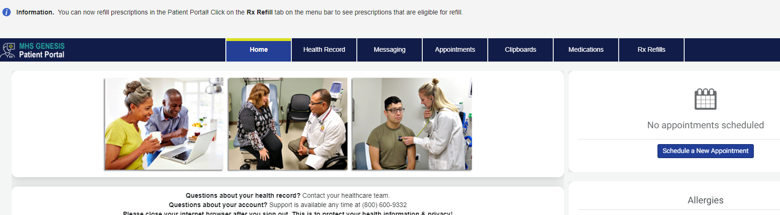

2. In the New Message menu, select "Send a message"

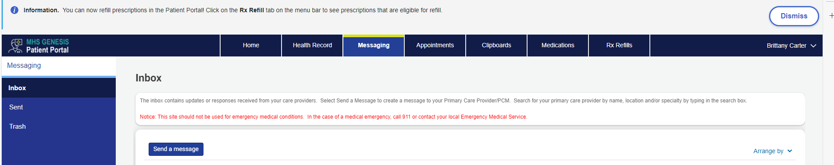

3. In the “To” field, search for the appropriate clinic name:

**Travis Ophthalmology Refractive Clinic**

4. Type the subject – “**Dependent and Retiree Application for Refractive Surgery**”, attach completed application and write your message.

5. Click Send

